1. 
2. In last lecture, we configured our app to handle deserialization error and then send the messages causing errors to Dead Letter Topic.
3. What if Email Notification MS couldn’t send Email Notification due to other errors like
   1. Email Server is down temporarily.   
      In this case, our app consumed the msg from the kafka topic successfully as no format error.  
      It is our MS that it is not able to process the msg successfully.
4. What we can do then?
5. We need to identify if the error that took place is recoverable or not like if email server is down for a few seconds, then retrying may help but if it is not recoverable like NullPointerException, then retrying will not work. Then publish MSG to Dead Letter Topic (DLT).
6. In the following lectures, we will see how to do retry in case of msg is recoverable and if not then how to send to DLT.  
   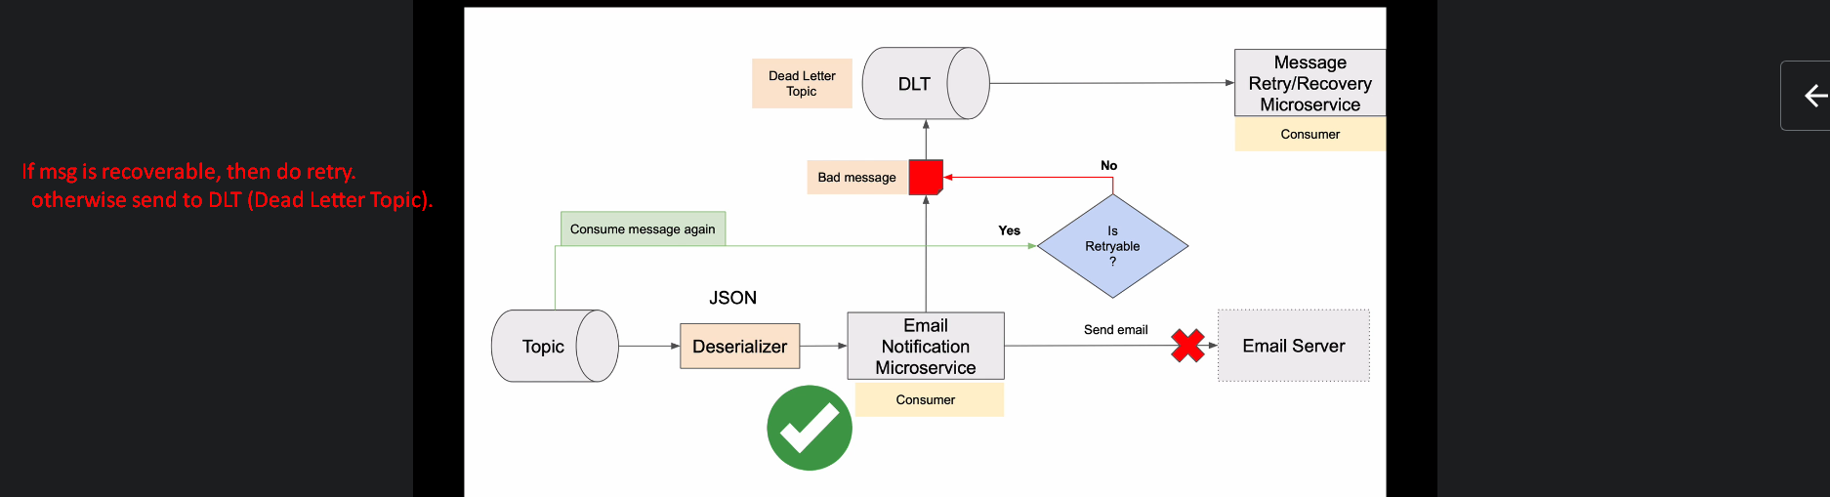  
     
   
7. **NOTE**: Jatin -> Retry is performed only if msg marshalling is done successfully and exception occurs later on.  
   if during marshalling, exception occurs, the msg will be published to DLT without any second thought.